Showing error Missing artifact com.oracle ojdbc6.jar while adding oracle jar file in pom.xml file

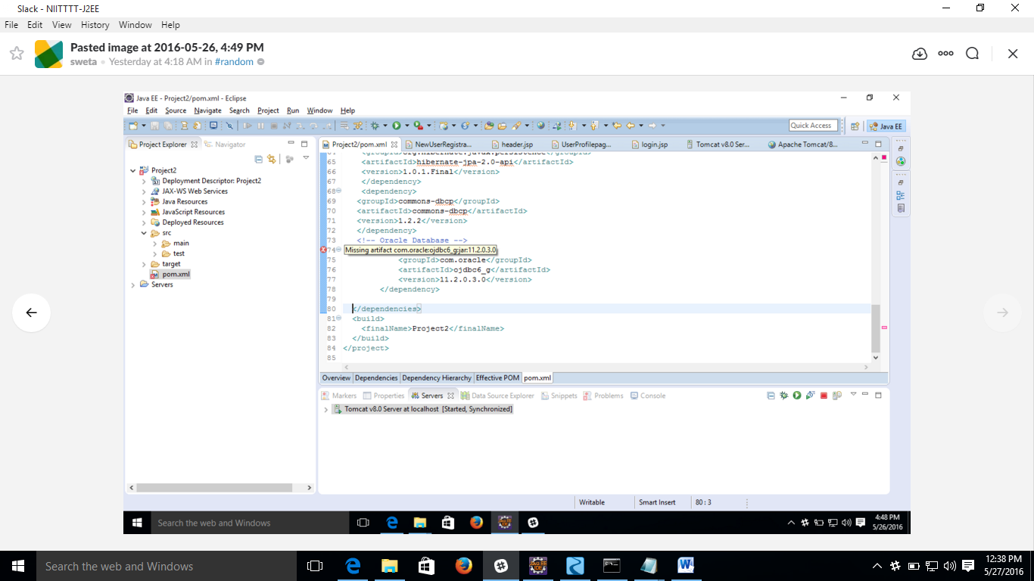

Due to the binary license there is no public repository with Oracle driver jar,

(link-http://www.oracle.com/technetwork/java/javase/terms/license/index.html)

To add oracle driver jar in our maven project we have to follow the following steps.

(uri follow-http://stackoverflow.com/questions/1074869/find-oracle-jdbc-driver-in-maven-repository)

1)download odbc6.jar file from oracle.com site

2)open the command prompt and Go to project directory where pom.xml file available.

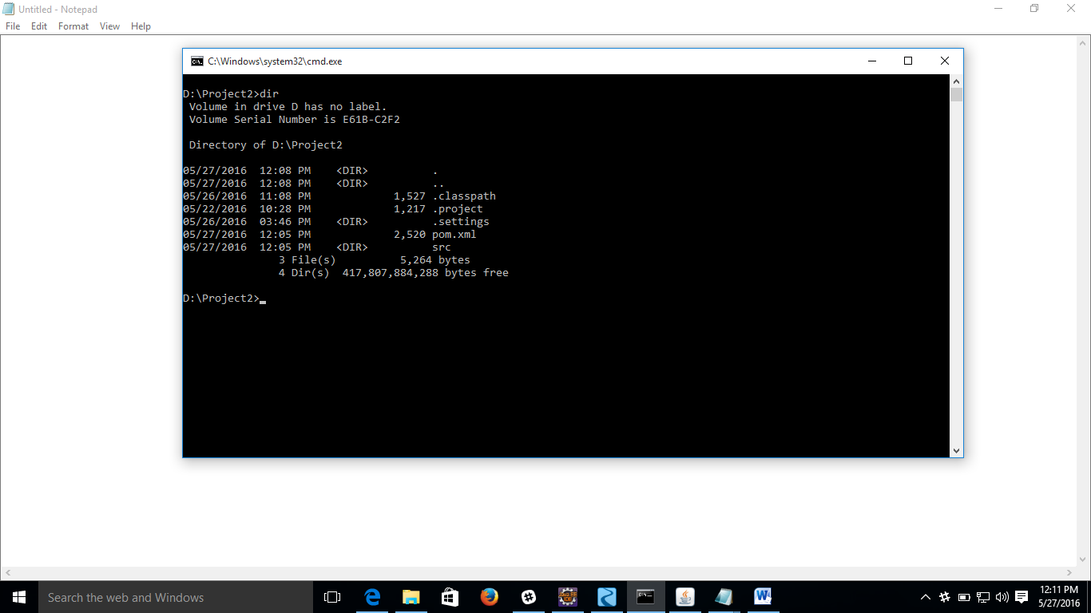

3)first type mvn clean in cmd

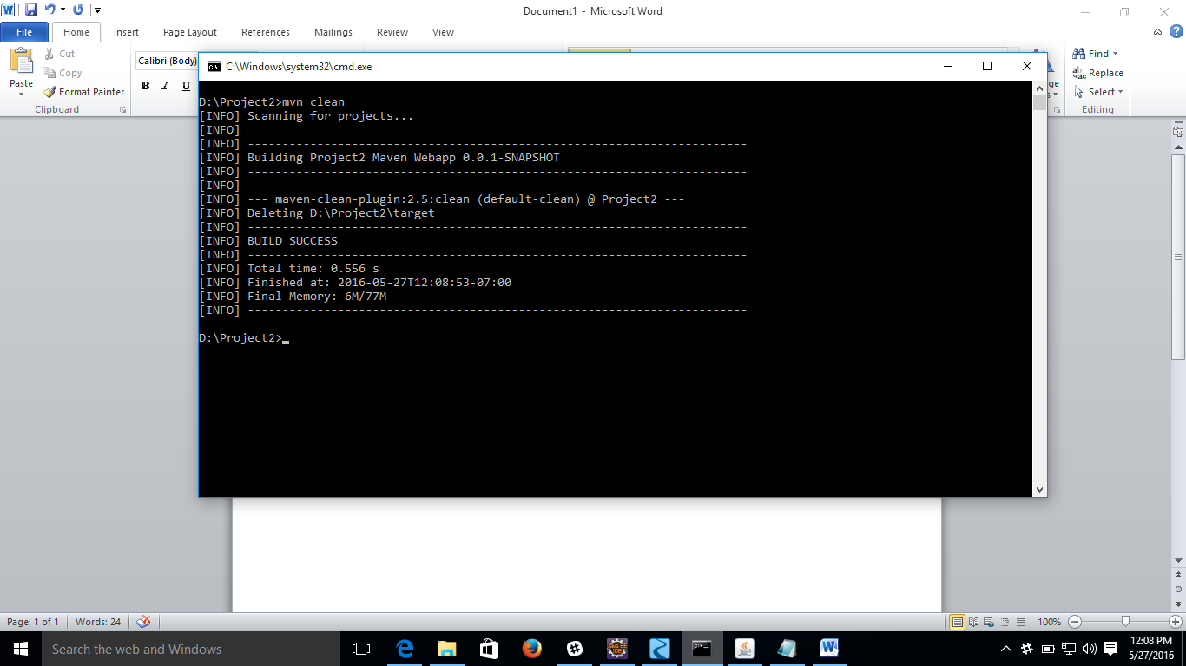

4) type mvn install:install-file -Dfile=C:\Users\asus\Downloads\ojdbc6.jar -DgroupId=com.oracle -DartifactId=ojdbc6 -Dversion=11.2.0 -Dpackaging=jar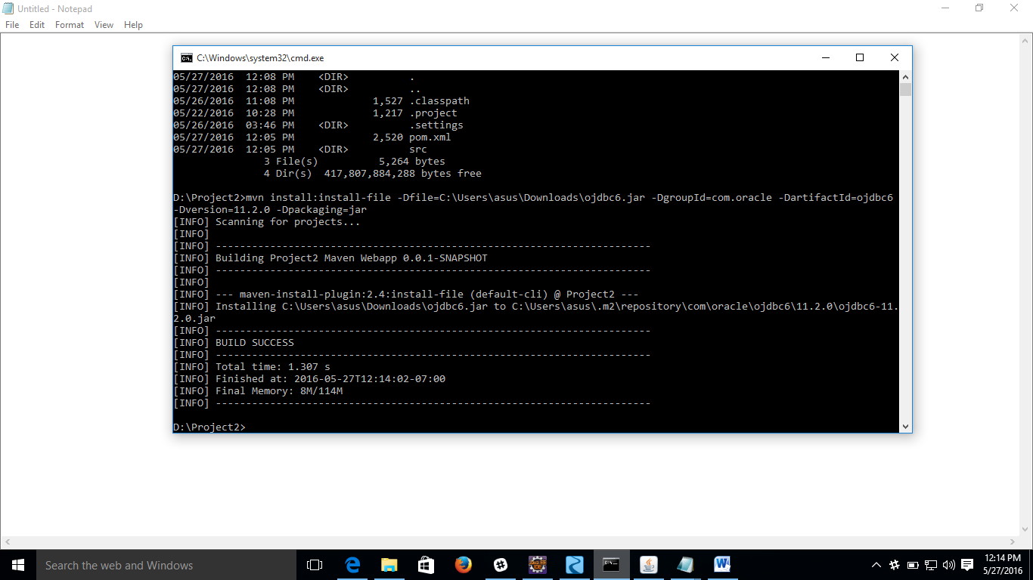

Note- to check odjbc6.jar added or not go to window-show view-other

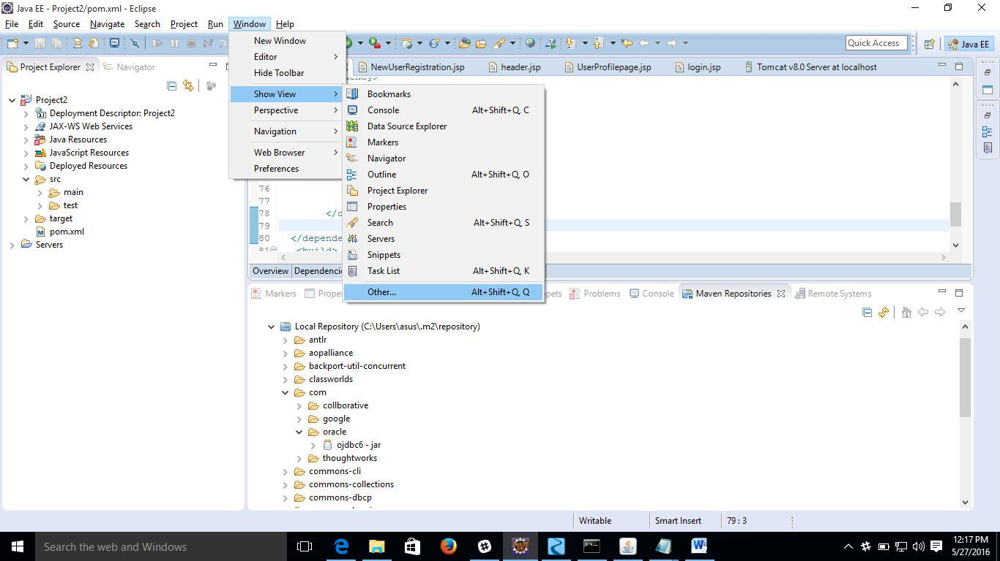

And type maven Repositories

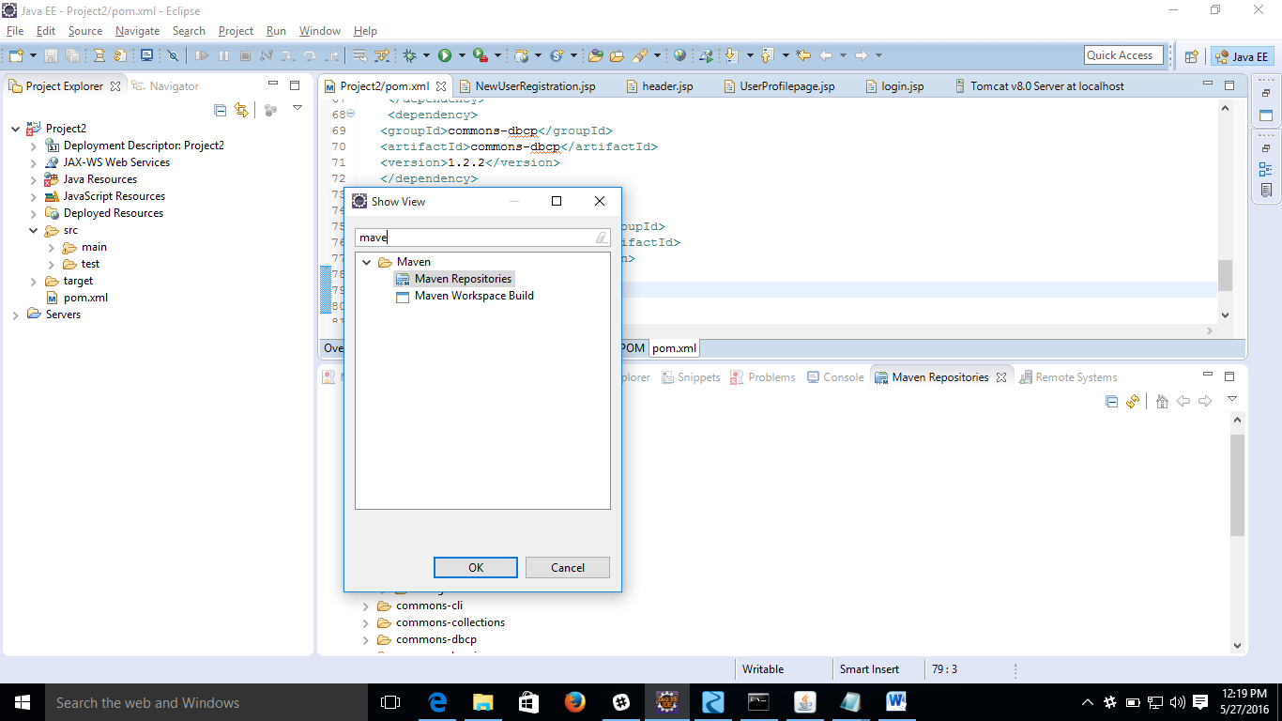

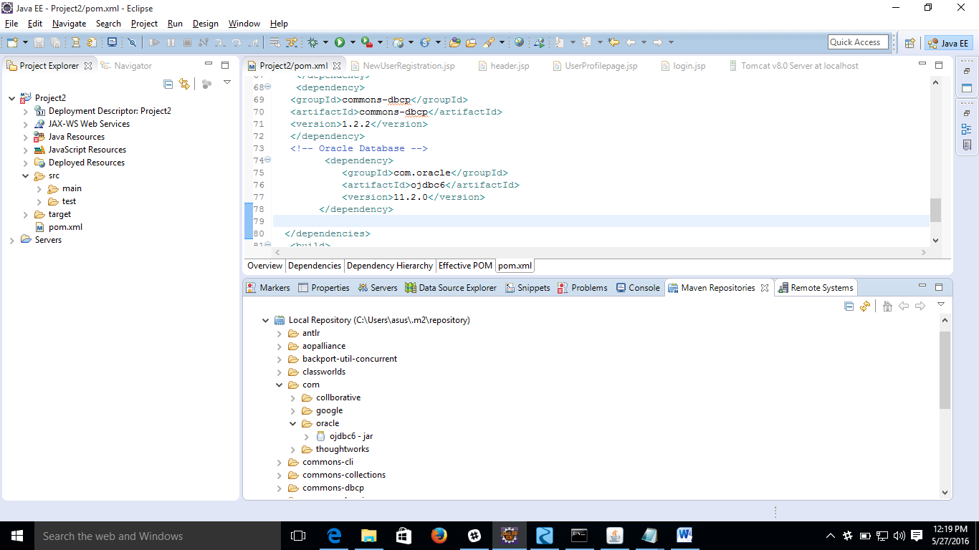

5)Type the following command the pom.xml file

<dependency>

<groupId>com.oracle</groupId>

<artifactId>ojdbc6</artifactId>

<version>11.2.0</version>

</dependency>